Earthing system
International standard IEC 60364 distinguishes three families of earthing arrangements, using the two-letter codes TN, TT, and IT.
The first letter indicates the connection between earth and the power-supply equipment (generator or transformer):
T
Direct connection of a point with earth (Latin: terra);
I
No point is connected with earth (isolation), except perhaps via a high impedance.
The second letter indicates the connection between earth and the electrical device being supplied:
T
Direct connection of a point with earth
N
Direct connection to neutral at the origin of installation, which is connected to the earth

The conductor that connects the exposed metallic parts of the consumer is called protective earth (PE). The conductor that connects to the star point in a three-phase system, or that carries the return current in a single-phase system, is called neutral (N). Three variants of TN systems are distinguished:

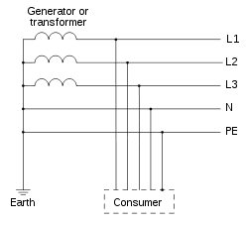 | 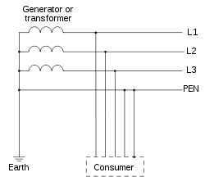 | 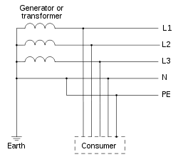
TN-S: separate protective earth (PE) and neutral (N) conductors from transformer to consuming device, which are not connected together at any point after the building distribution point. | TN-C: combined PE and N conductor all the way from the transformer to the consuming device. | TN-C-S earthing system: combined PEN conductor from transformer to building distribution point, but separate PE and N conductors in fixed indoor wiring and flexible power cords.

IT network
In an IT network, the distribution system has no connection to earth at all, or it has only a high impedance connection. In such systems, an insulation monitoring device is used to monitor the impedance. For safety reasons this network is not accepted under European norms.
